**Short Term Trading Blending IPDA Data Ranges & PD Arrays**

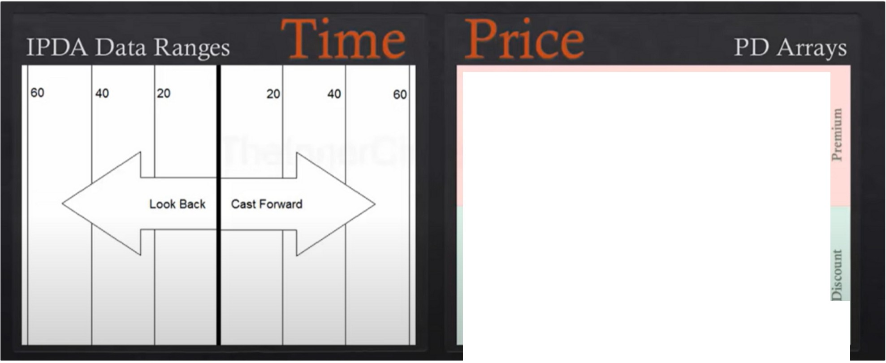

Old High or Low RcJection Block Beansh Ordffl.>lock Fair \'alut Gap Liquidity \'oid Bearish Brtaker

Beansh litigauon Block

**Marl<et Price**

Bullish Mill/',ahon Bl k BullisbBre;ik,r L1qu1J1ty \'01d

**au \'alut Gap** Bullish Ordntlock **Rtj<aionB**

Old **Low or** High

**PD Array Matrix**

Blending time and price with IPDA data ranges and PD arrays Each new day you shift the IPDA data range forward

Which array to use on the IPDA data range, thats when we look at the PD array matrix

So we look back 20 days and look above market price to see which premium arrays exists in price action, looking back 20 days which discount arrays exists below us.

There may be a PD array thats already been used, like an orderblock price has already trade into and responded accordingly with higher/lower prices. That PD array has been exhausted so we no have look at another PD array

We combine time and price like the algorithm

When were in a bearish market we will work from premium to discount, based on whatever premium arrays exist in the current market action when bearish, those premium arrays will be resistance points where sell offs will occur or new sell setups. The objective for price will be to reach into the discount array that exist in price action. We dont force the PD arrays, if theres an absence of one it doesnt make the setup less valid, it just means you have far less to choose from in targets or setups

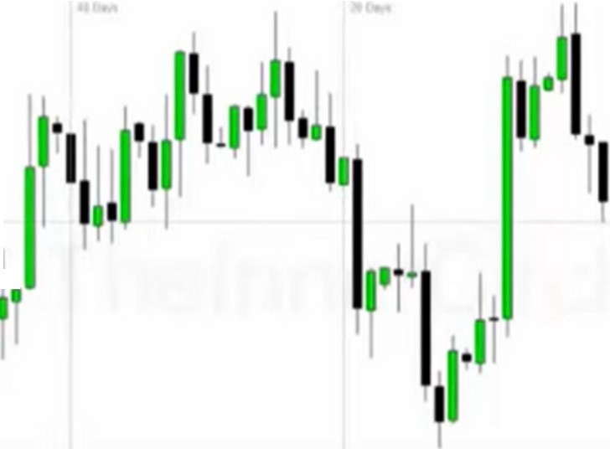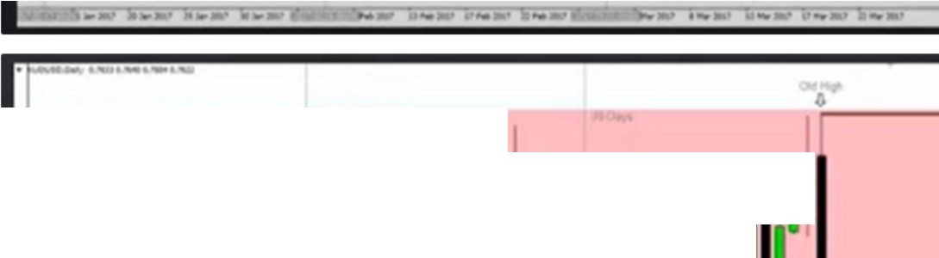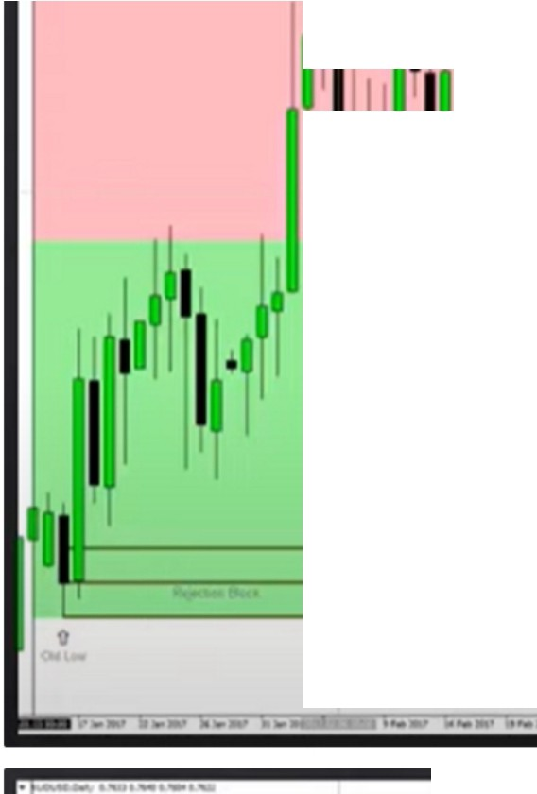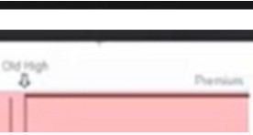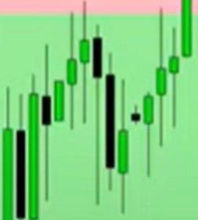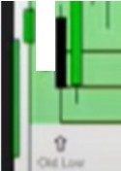

# I I l

l

i

111-II,

* **11**' .

.

·.­

I I I I

I

II II I 11

I

I I I

I

**li** 11 I**11**· 'I

I I**11•**I**,, l.1** I,i 1ri

I , I' I 11I

# I

I 'I

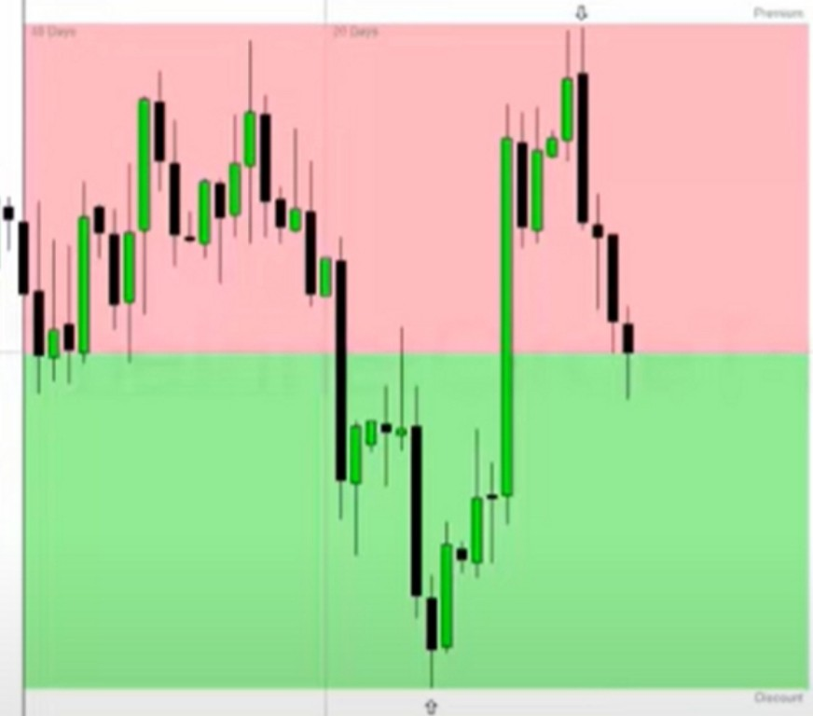This is our 60 day trading range, with our premium and discount

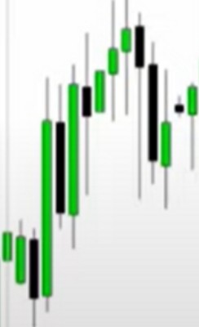

Last 40 day range

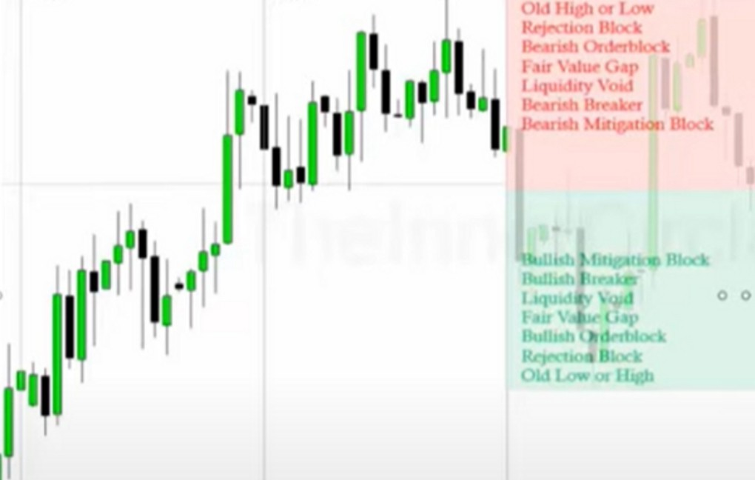

**Marilet Price**

**PO Ar *V* M trlx**

Last 20 day lookback with PD array matrix

These are the PD arrays in the last 20 trading days, on a daily timeframe Mean threshold in terms of the bodies not the wicks

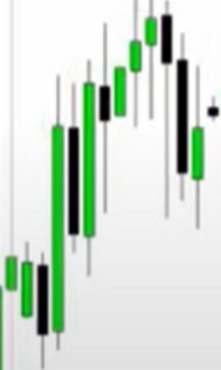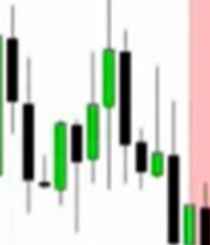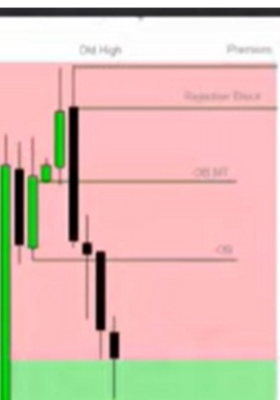

. I

1I111'1

I I

I I

,1·tII **,·**. **•1-----**

**11.._**

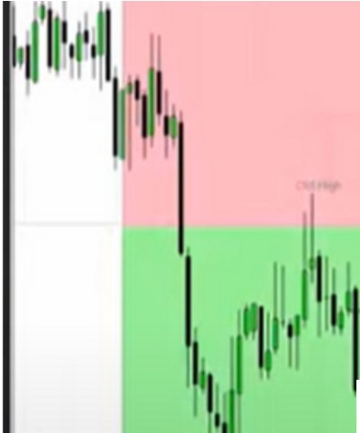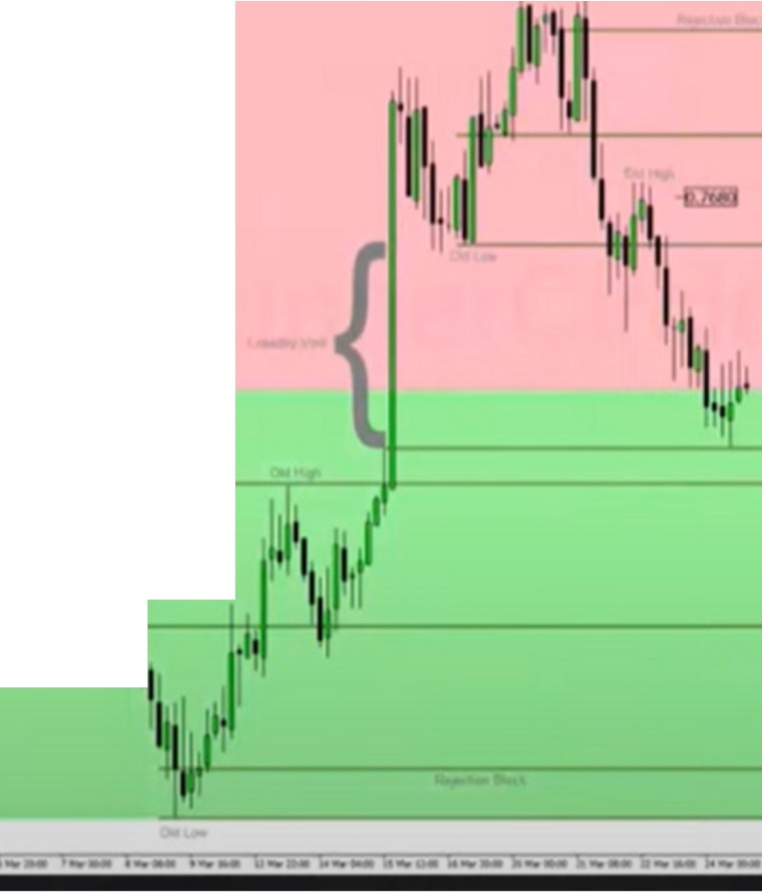

--

**'t**

I

4h chart, much more detail, you can see how price moves from one PD array to the next Tuesday failed to make a higher high and broke down

Its not required for you all the time to know exactly where price will go, if you fail in your analysis it will give you an immediate reason to reverse the idea and take trades in the opposite direction

If we go short on a daily PD array we will be looking for a lesser timeframe PD array to target, a 4h or 1h

Notice how we close the void in the discount range coming from a premium range

So he used the daily high premium array that got swept on tuesday, and looked for a lesser timeframe discount array to target on the 4h or 1h and that came in the form of the liquidity void

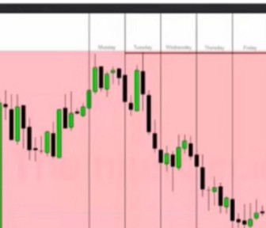

.. ,.

..,, ,,,.,

**11** •'

I

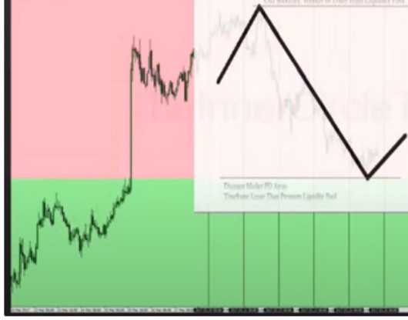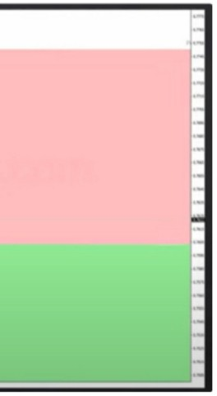

lloftdly Tlltld,J Wtdllttday 1"'ndliy fnd,J

Everything together we have time and price blended, and mixing that with the weekly profiles we have symmetry in the market place that would otherwise likely escape anyone else

Arjo I Twitter, lnstagram I Linktree

Linktree. Make your link do more.

I https://t.co/HhmmTN1fUI

JavaScript is not available.

"# https://twitter.com/arjoio